## 结果截图

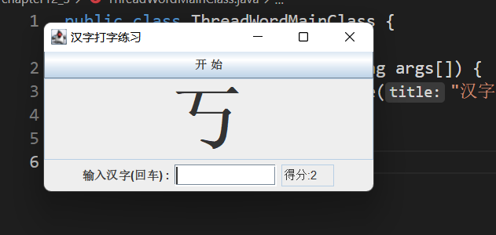

## 代码截图

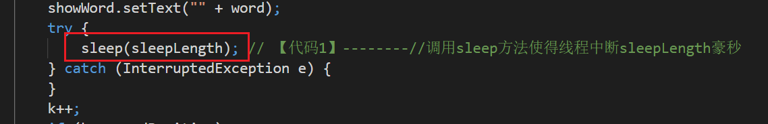

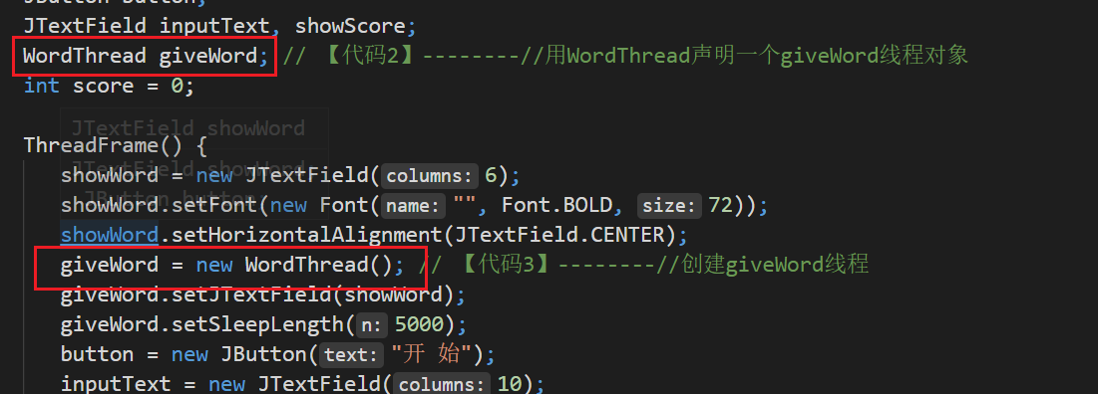

## 

## 源码

public class ThreadWordMainClass {

public static void main(String args[]) {

new ThreadFrame().setTitle("汉字打字练习");

}

}

//

import javax.swing.JTextField;

public class WordThread extends Thread {

char word;

int startPosition = 19968; // Unicode表的19968位置至32320上的汉字

int endPosition = 32320;

JTextField showWord;

int sleepLength = 6000;

public void setJTextField(JTextField t) {

showWord = t;

showWord.setEditable(false);

}

public void setSleepLength(int n) {

sleepLength = n;

}

public void run() {

int k = startPosition;

while (true) {

word = (char) k;

showWord.setText("" + word);

try {

sleep(sleepLength); // 【代码1】--------//调用sleep方法使得线程中断sleepLength豪秒

} catch (InterruptedException e) {

}

k++;

if (k >= endPosition)

k = startPosition;

}

}

}

//

import java.awt.*;

import java.awt.event.*;

import javax.swing.*;

public class ThreadFrame extends JFrame implements ActionListener {

JTextField showWord;

JButton button;

JTextField inputText, showScore;

WordThread giveWord; // 【代码2】--------//用WordThread声明一个giveWord线程对象

int score = 0;

ThreadFrame() {

showWord = new JTextField(6);

showWord.setFont(new Font("", Font.BOLD, 72));

showWord.setHorizontalAlignment(JTextField.CENTER);

giveWord = new WordThread(); // 【代码3】--------//创建giveWord线程

giveWord.setJTextField(showWord);

giveWord.setSleepLength(5000);

button = new JButton("开 始");

inputText = new JTextField(10);

showScore = new JTextField(5);

showScore.setEditable(false);

button.addActionListener(this);

inputText.addActionListener(this);

add(button, BorderLayout.NORTH);

add(showWord, BorderLayout.CENTER);

JPanel southP = new JPanel();

southP.add(new JLabel("输入汉字(回车) :"));

southP.add(inputText);

southP.add(showScore);

add(southP, BorderLayout.SOUTH);

setBounds(100, 100, 350, 180);

setVisible(true);

validate();

setDefaultCloseOperation(JFrame.EXIT_ON_CLOSE);

}

public void actionPerformed(ActionEvent e) {

if (e.getSource() == button) {

if (!(giveWord.isAlive())) {

giveWord = new WordThread(); // 【代码4】--------////创建giveWord

giveWord.setJTextField(showWord);

giveWord.setSleepLength(5000);

}

try {

giveWord.start(); // 【代码5】--------//giveWord调用start()方法

} catch (Exception exe) {

}

} else if (e.getSource() == inputText) {

if (inputText.getText().equals(showWord.getText()))

score++;

showScore.setText("得分:" + score);

inputText.setText(null);

}

}

}

//

import java.awt.*;

import java.util.Scanner;

public class InuptLetterThread extends Thread {

Scanner reader;

Letter letter;

int score = 0;

InuptLetterThread() {

reader = new Scanner(System.in);

}

public void setLetter(Letter letter) {

this.letter = letter;

}

public void run() {

while (true) {

// System.out.printf("输入显示的字母(回车)\n"));

String str = reader.nextLine();

char c = str.charAt(0);

if (c == letter.getChar()) {

score++;

System.out.printf("\t\t输入对了,目前分数%d\n", score);

} else {

System.out.printf("\t\t输入错了,目前分数%d\n", score);

}

if (c == '#')

System.exit(0);

}

}

}